**GUIDELINES FOR APP INSTALLATION ON A PHYSICAL DEVICE**

Contents

**GOOGLE DRIVE METHOD 2**

**FILE TRANSFER THROUGH USB METHOD 7**

# GOOGLE DRIVE METHOD

**STEP 1:** Go to this link from the device on which you intend to run the app: <https://drive.google.com/drive/1Fd0DVBVSIskbaKQoxqVAz>.

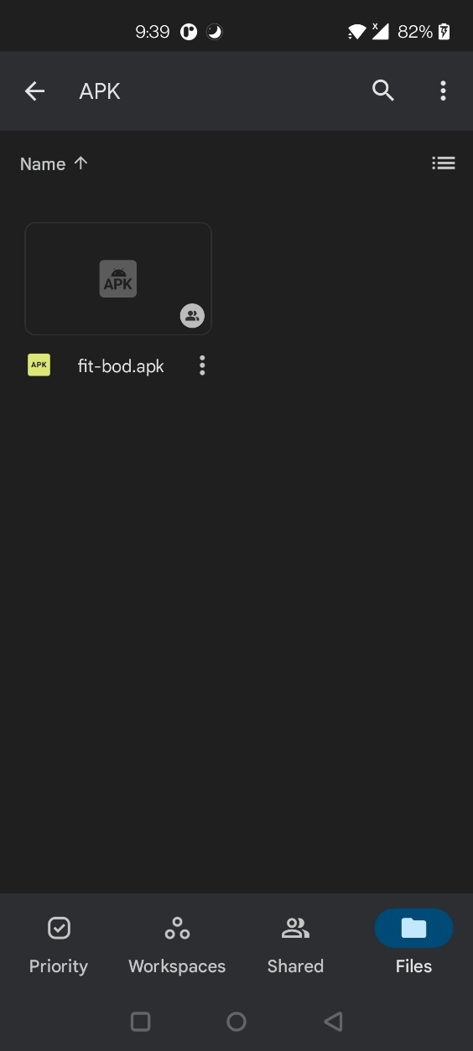

**STEP 2:** Press the three dots on the file titled fit-bod.apk. Here you will get an option to download the file, click Download. Your file will start downloading.

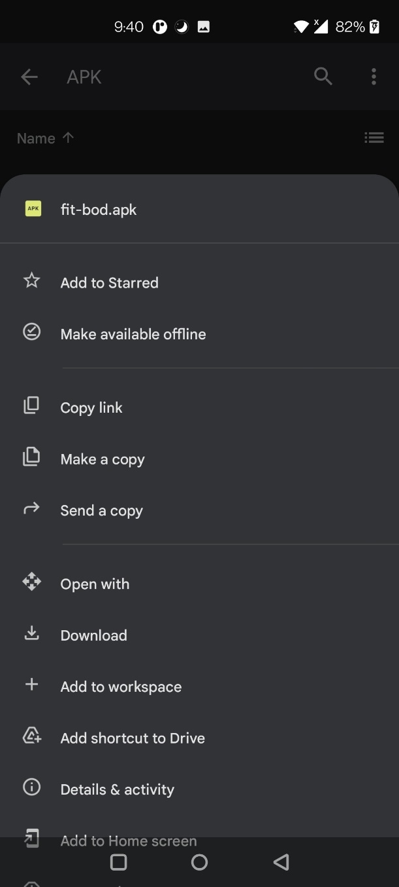 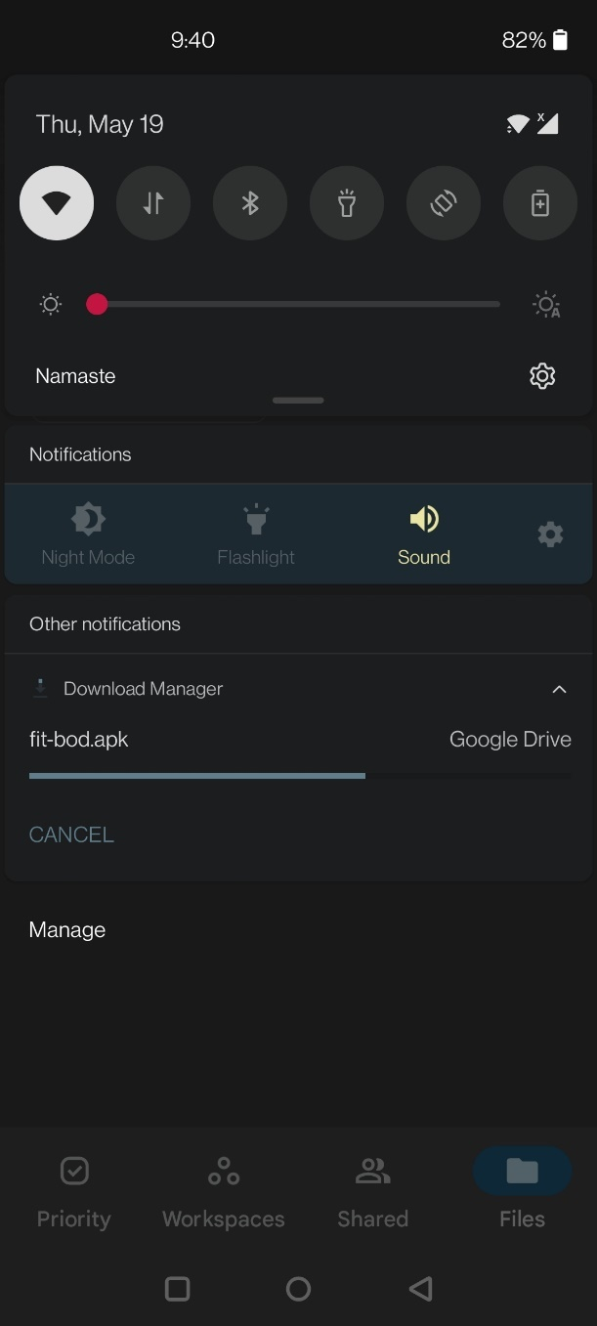

**STEP 3:** Form the notification panel click the notification which will take you to the download location of the file. Press the downloaded file.

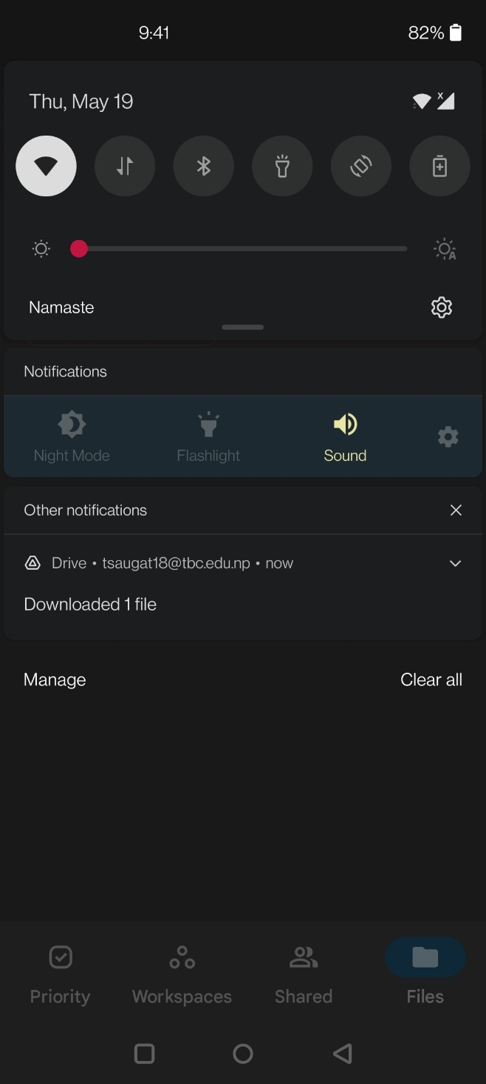 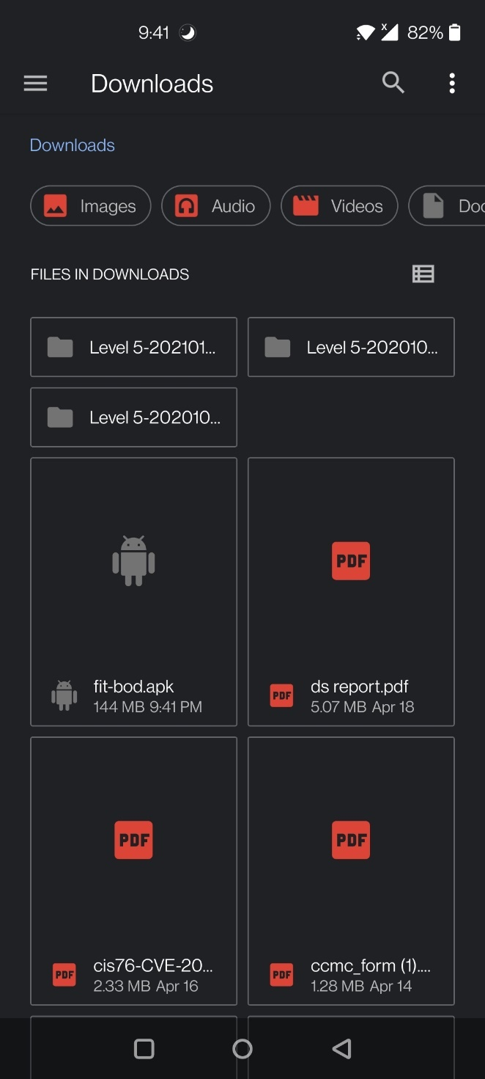

**STEP 4:** It will now give you an ‘INSTALL’ option, click on it. The app is now installing.

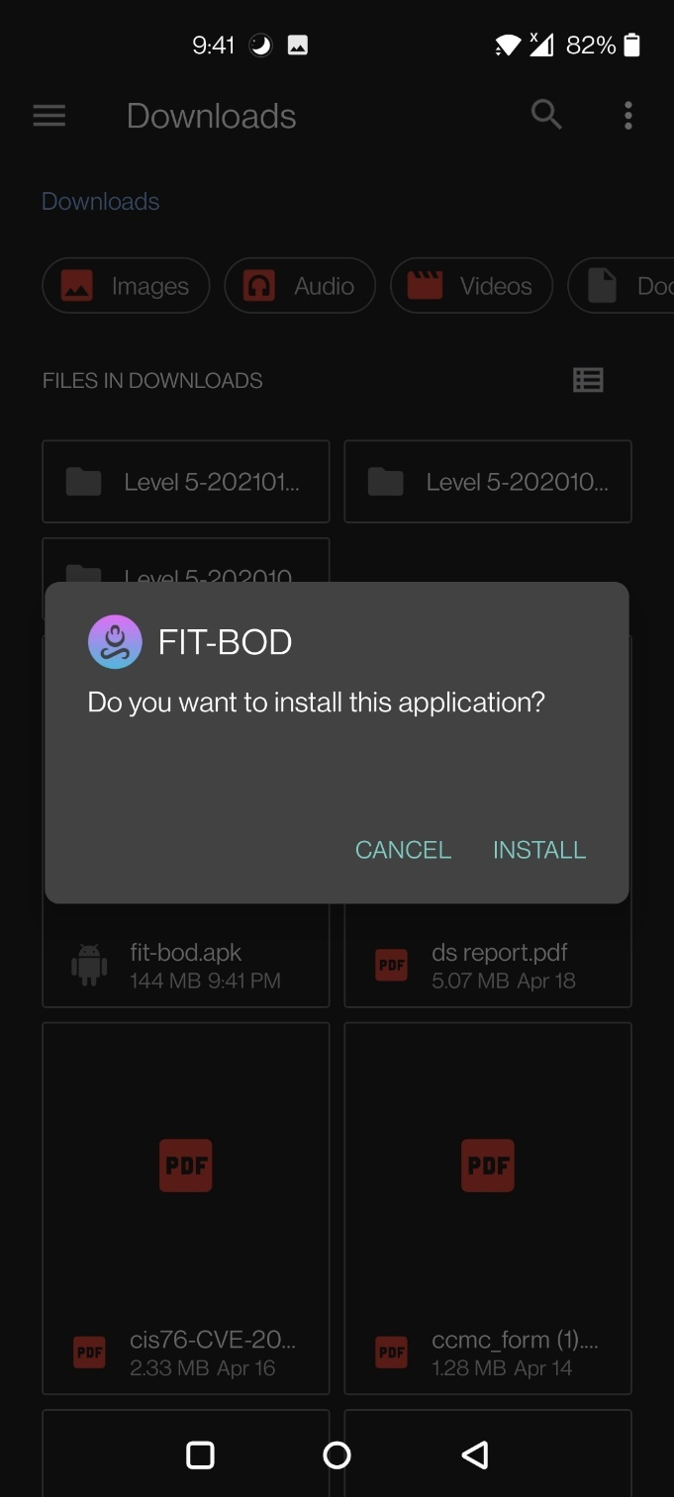 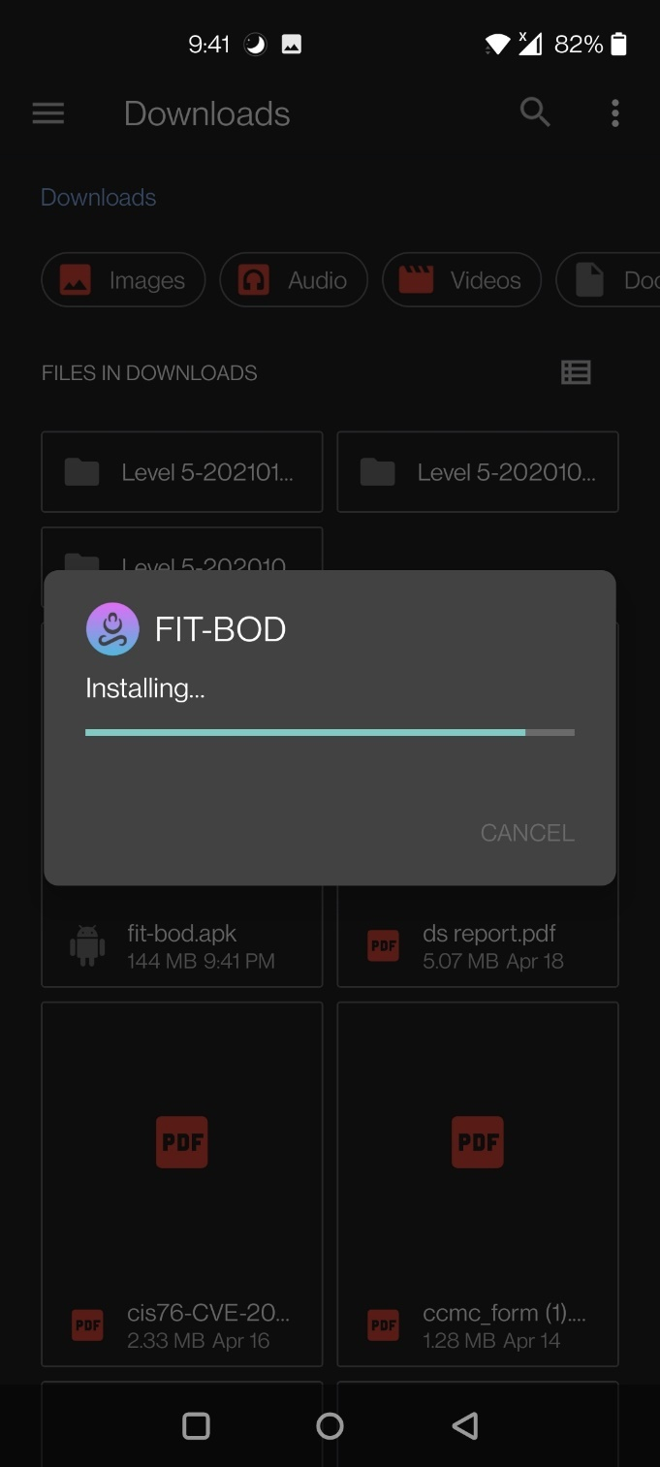

**STEP 5:** Press open

.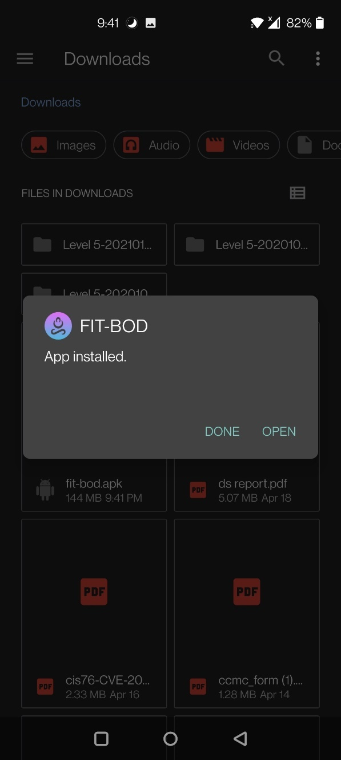 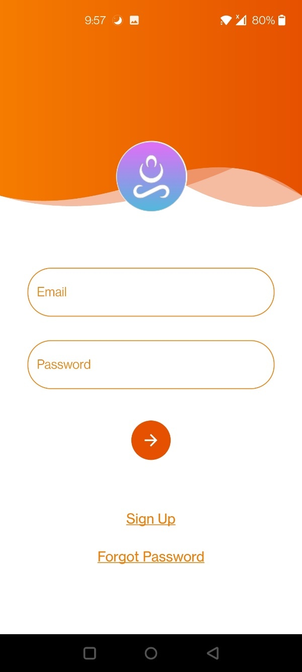

# FILE TRANSFER THROUGH USB METHOD

Alternatively, transfer the **apk file present in this folder** to your device through some medium like USB cable. Follow the below steps:

**STEP 1:** Locate your device

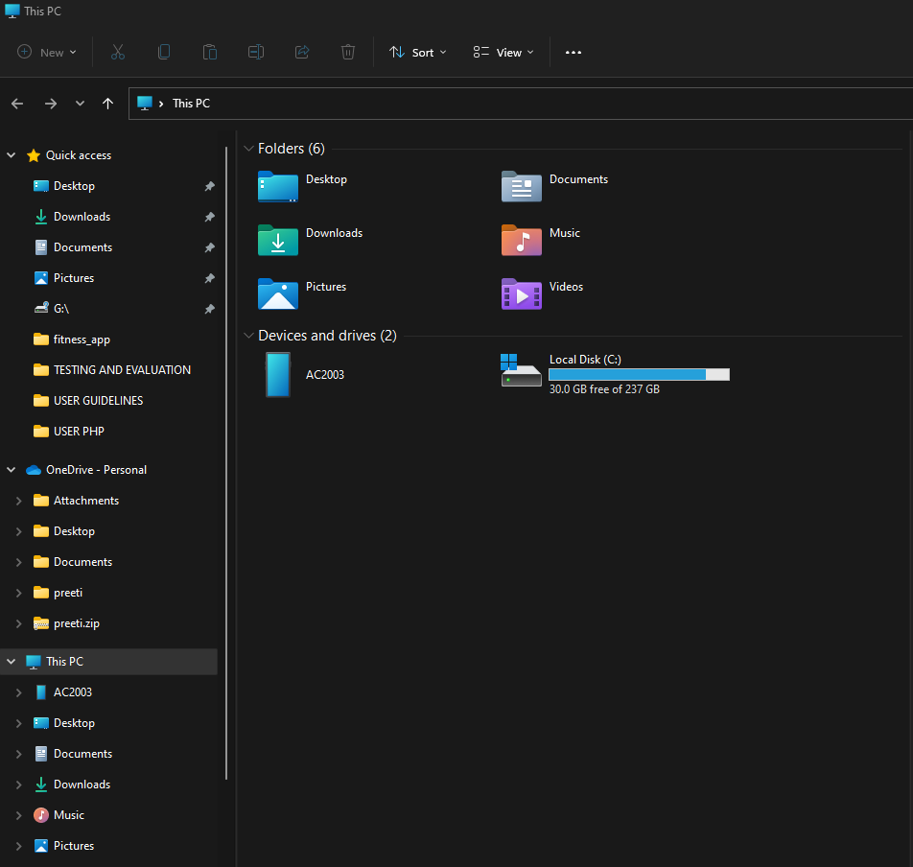

**STEP 2:** Locate the downloads folder within the device

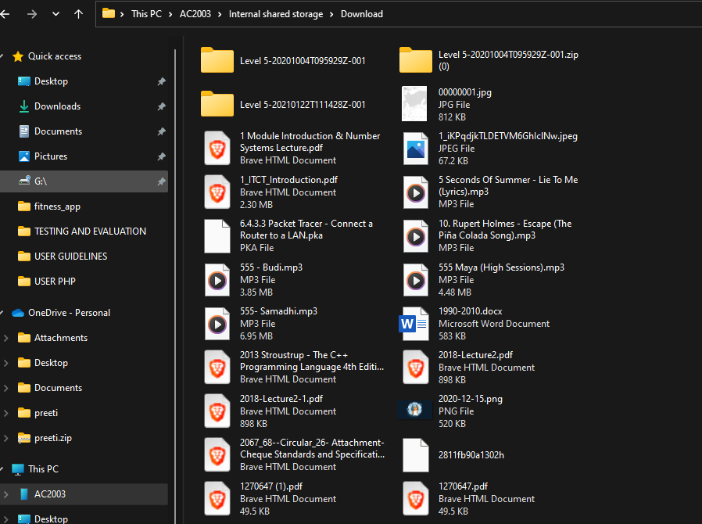

**STEP 3:** Copy and paste the APK file from this folder to the Device downloads folder

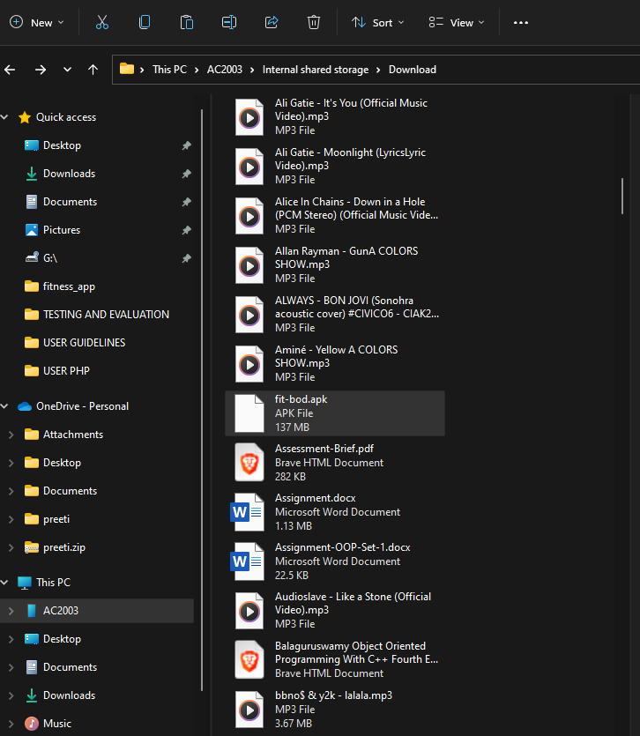

**STEP 4:** Locate the APK file location in the device

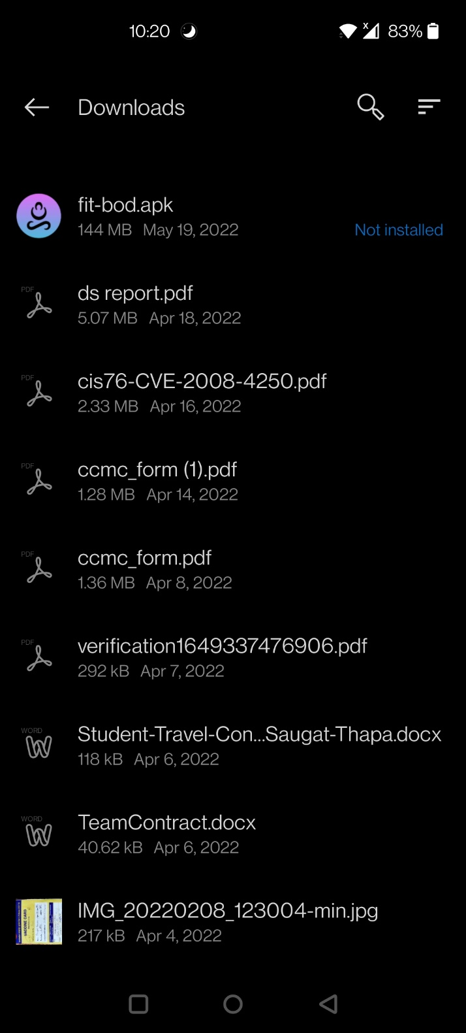

**STEP 5:** Give permission to install apps from unknown sources

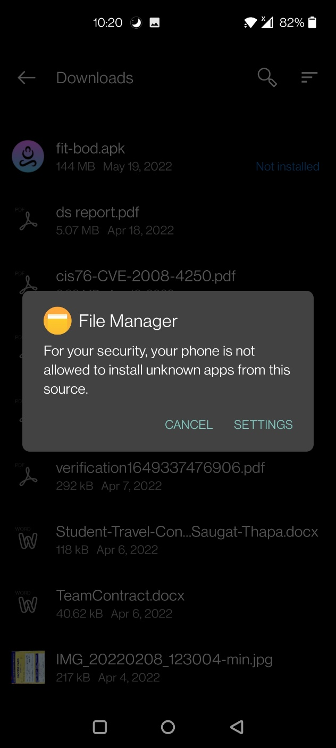 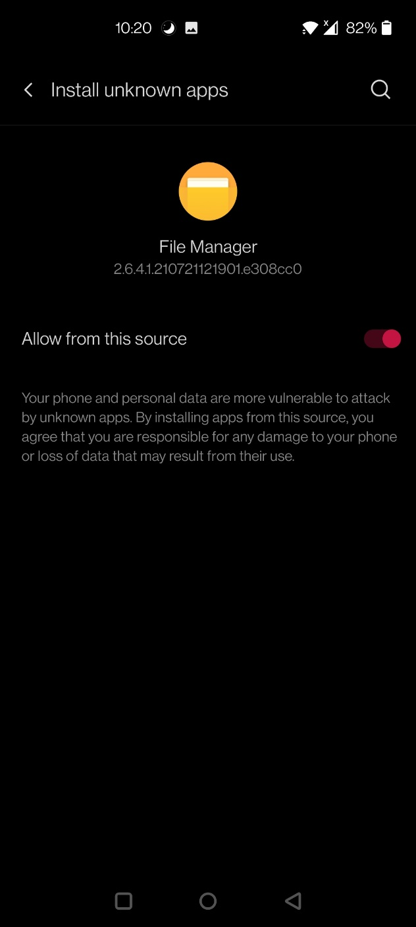

**STEP 6:** Perform STEP 4 and 5 from **GOOGLE DRIVE METHOD**